Task 1
Write a C program where a parent process creates multiple child processes and synchronizes their completion using wait() and waitpid(). Compare the behaviour of both functions.
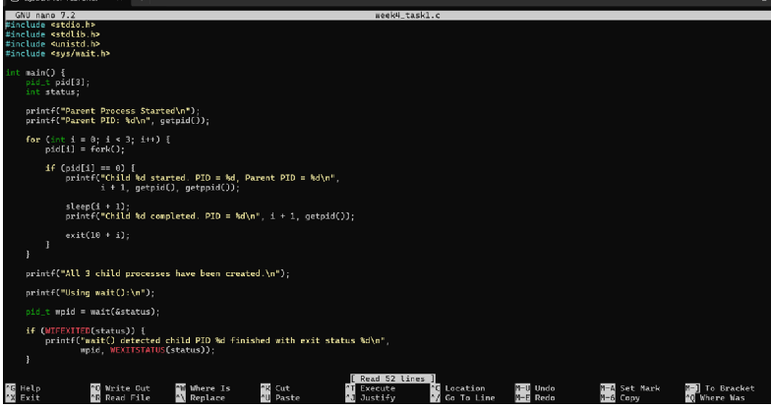
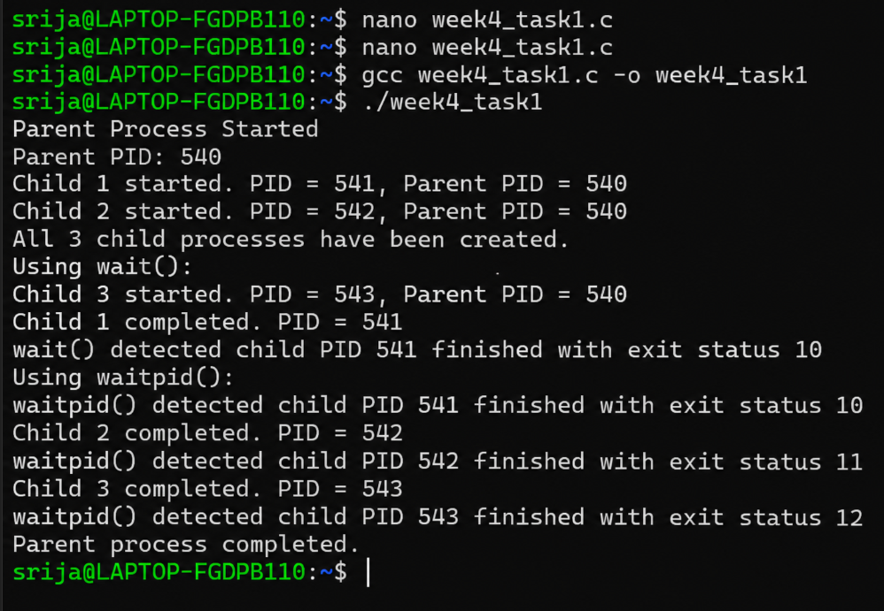
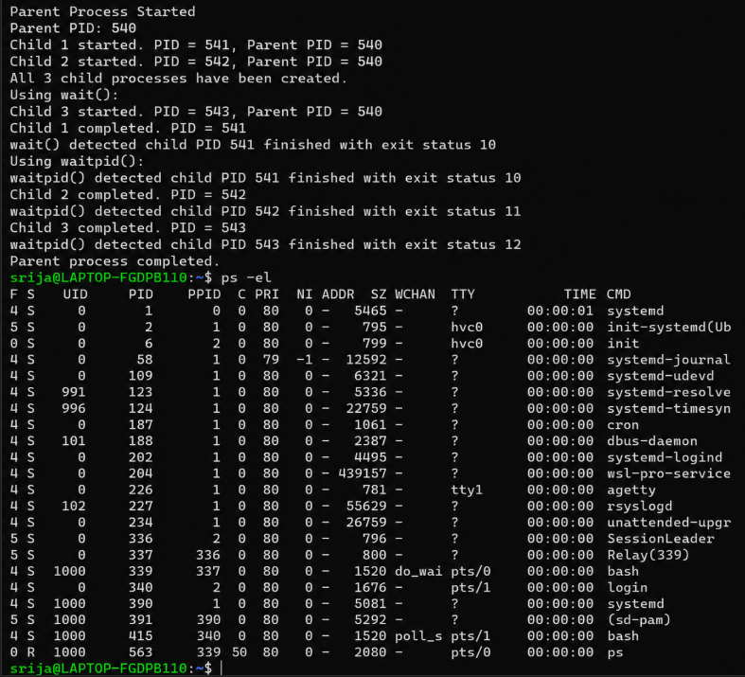
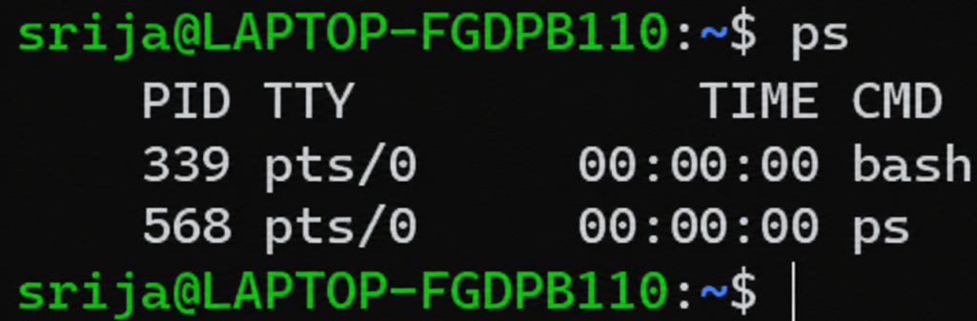
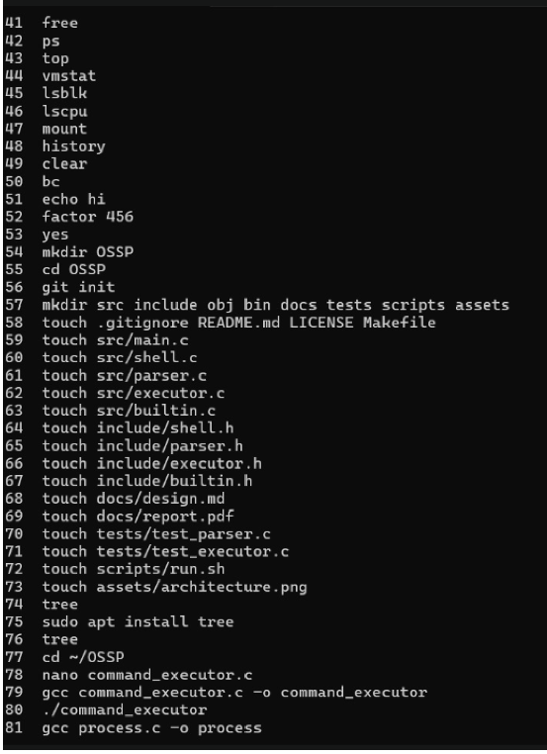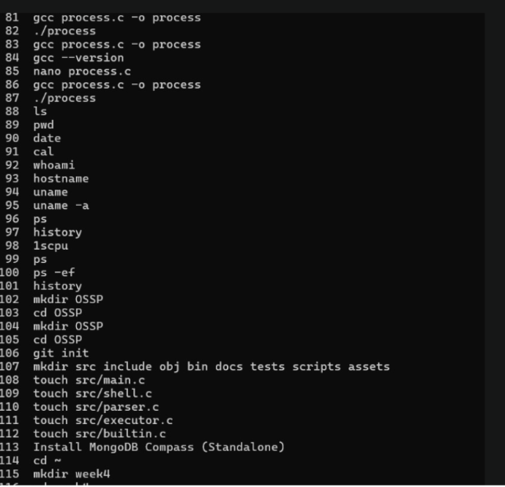
A parent process can create multiple child processes using the fork() system call. After creating the child processes, the parent may need to wait for them to complete before continuing.
The wait() function allows the parent process to wait until any one child process finishes.
The waitpid() function gives more control because the parent can wait for a specific child process.
In this practical, three child processes are created. The parent uses wait() and waitpid() to synchronize their completion and identify when each child process has finished.

Task 2 Question
Create a scenario where a child process becomes a zombie process. Investigate the process table and then modify the program to eliminate zombie processes using proper synchronization techniques.
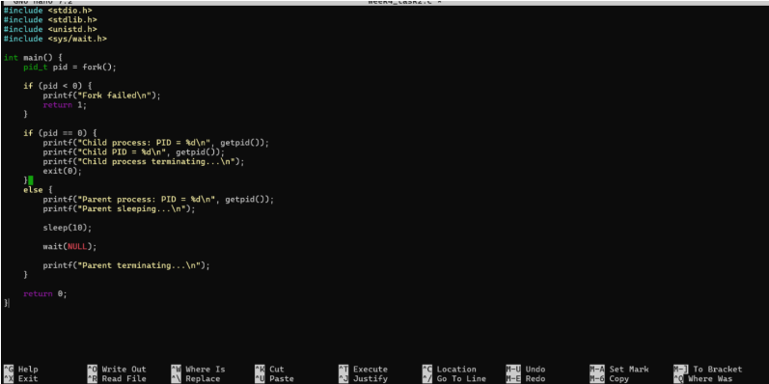

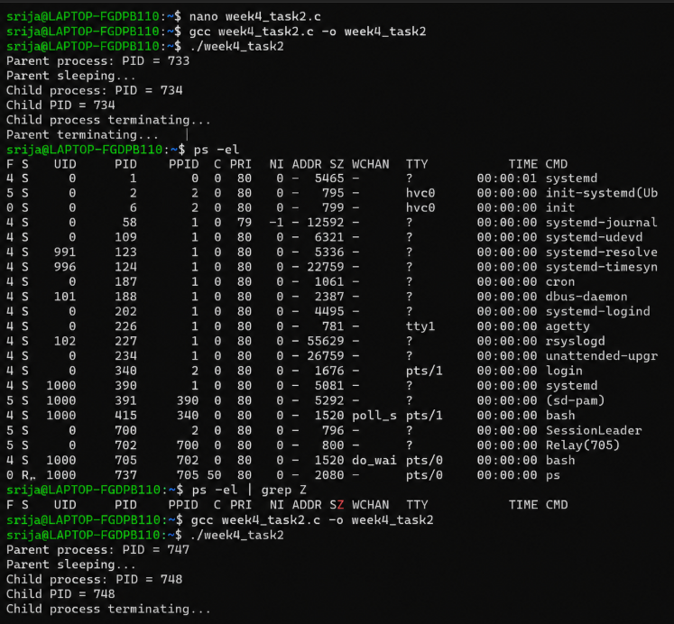Theory
A zombie process is a child process that has finished its execution, but its parent process has not yet collected its exit status. Because of this, the child remains in the process table.

